

STUDENT REGISTRATION SYSTEM

PART 3: DESIGN

COURSE: SOFTWARE ENGINEERING

Fall 2019

CLASS: MONDAY MORNING (LABORATORY)

SATURDAY MORNING (THEORY)

INSTRUCTOR: Ms. N.T.T.LOAN

**Member:**

Trịnh Minh Đăng ITITIU16022

Nguyễn Đức Phi Hồng ITITIU17022

Võ Huy Thành ITITIU17026

|  |
| --- |
| **MEMBER CONTRIBUTION** |

|  |  |  |
| --- | --- | --- |
| **NAME** | **ID** | **CONTRIBUTION** |
| **Nguyễn Đức Phi Hồng** | **ITITIU17022** | **III. ERD**  **II. SYSTEM ARCHITECTURE**  **V. SEQUENCE DIAGRAM**  **VI. ACTIVITY DIAGRAM** |
| **Trịnh Minh Đăng** | **ITITIU16022** | **V. SEQUENCE DIAGRAM**  **VI. ACTIVITY DIAGRAM** |
| **Võ Huy Thành** | **ITITIU17026** | **I. USECASE DIAGRAM**  **V. SEQUENCE DIAGRAM**  **VI. ACTIVITY DIAGRAM** |

**OUTLINE**

|  |
| --- |
|  |

**I. USE CASE DIAGRAM**

**II. SYSTEM ARCHITECTURE**

**III. ERD**

**IV. CLASS DIAGRAM**

**V. SEQUENCE DIAGRAM**

**VI. ACTIVITY DIAGRAM**

**I. USE CASE DIAGRAM**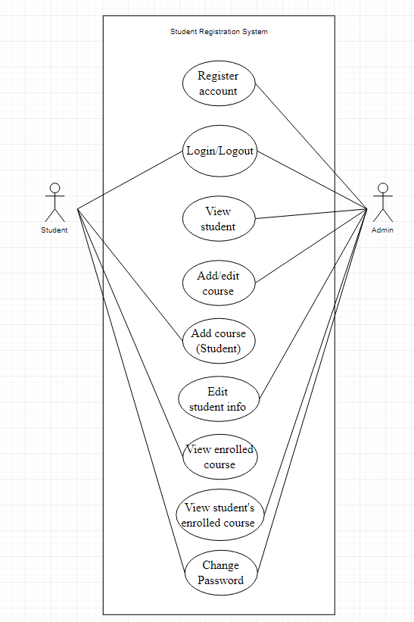

**II. SYSTEM ARCHITECTURE**

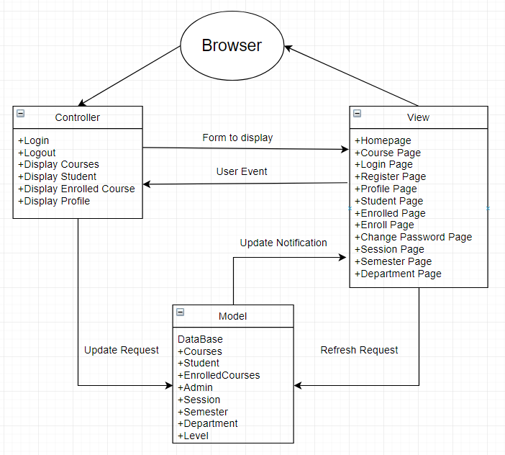

**III. ERD**

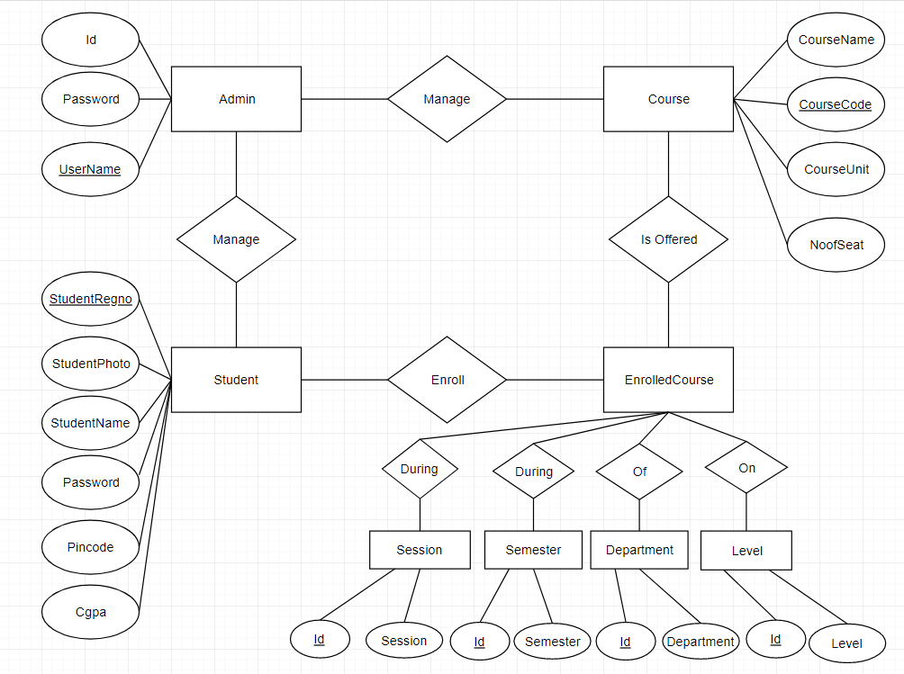

**IV. CLASS DIAGRAM**

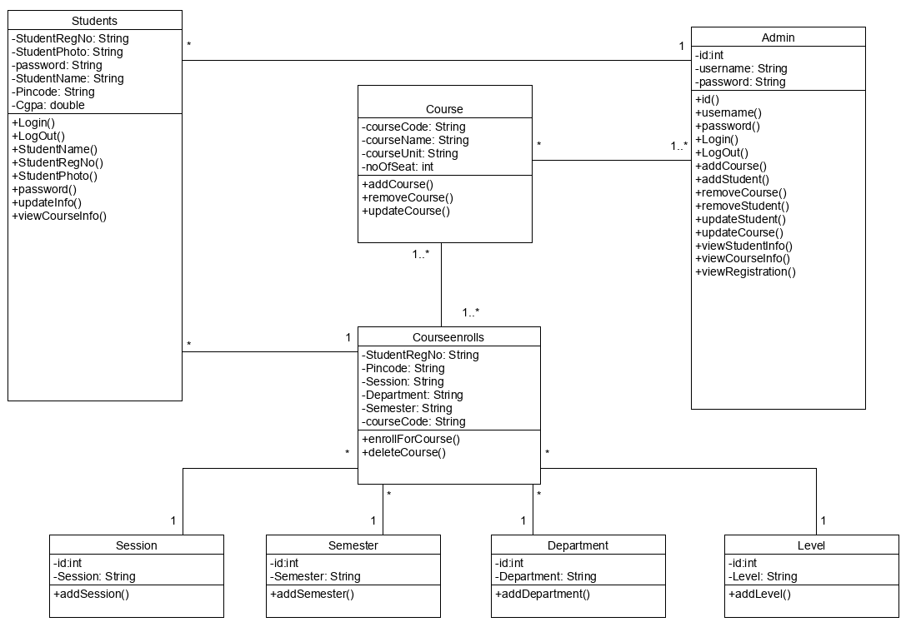

**V. SEQUENCE DIAGRAM**

UC1: Account Registration

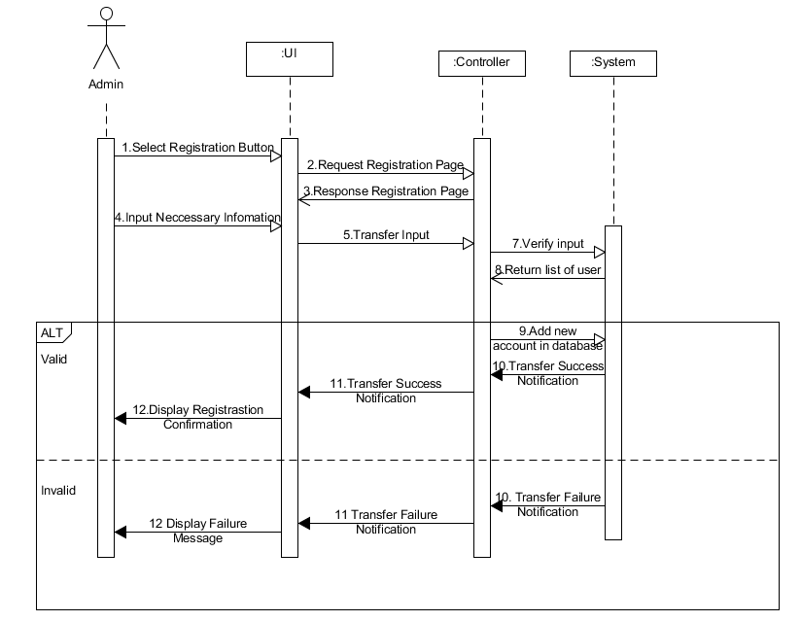

UC2: LOGIN / LOGOUT

UC2.1: Log in

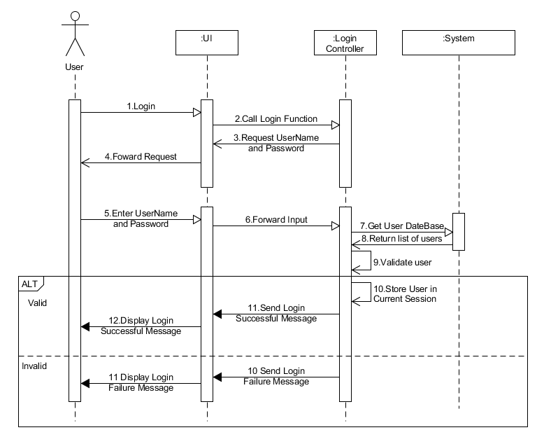

UC2.2: Log out

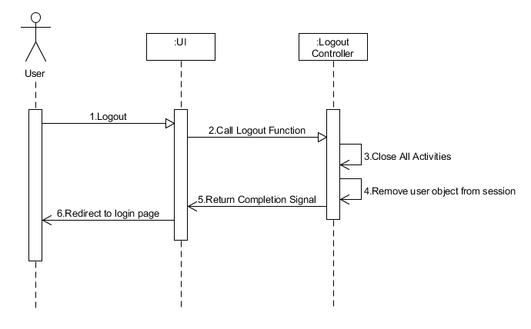

UC3: View student

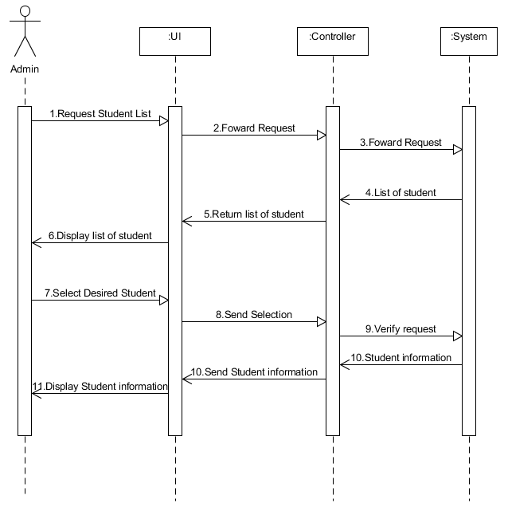

UC4: Add/Edit course

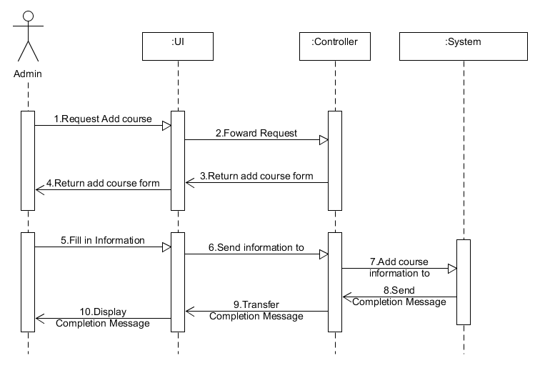

UC5: Add /Remove course (Student)

UC5.1: Add course (Student)

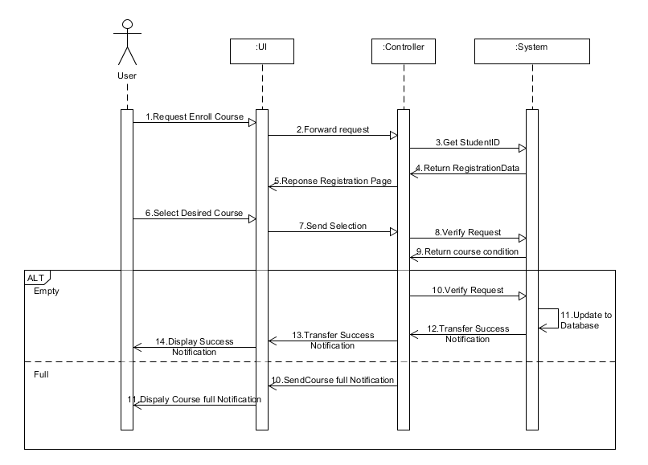

UC5.2: Remove course (Student)

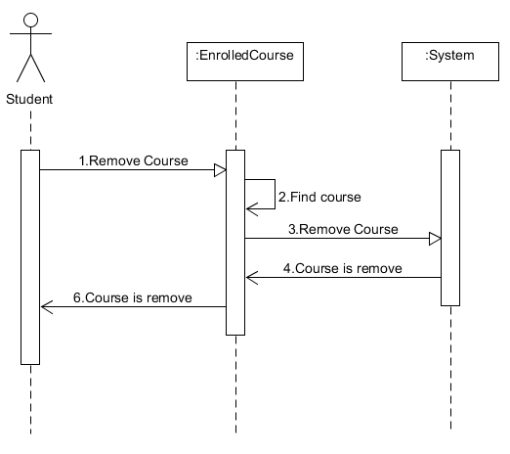

UC6: Edit student

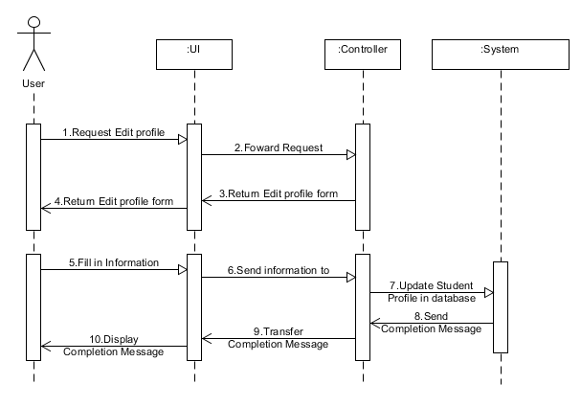

UC7: View enrolled course (Student)

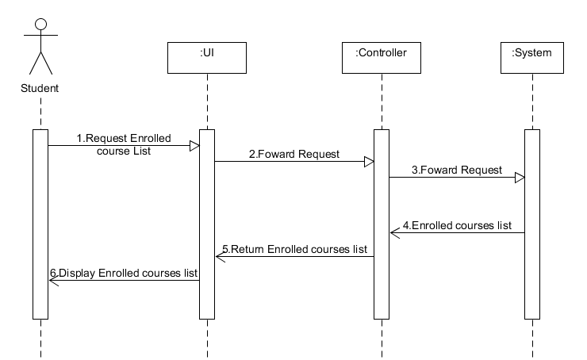

UC8: View enrolled course (Admin)

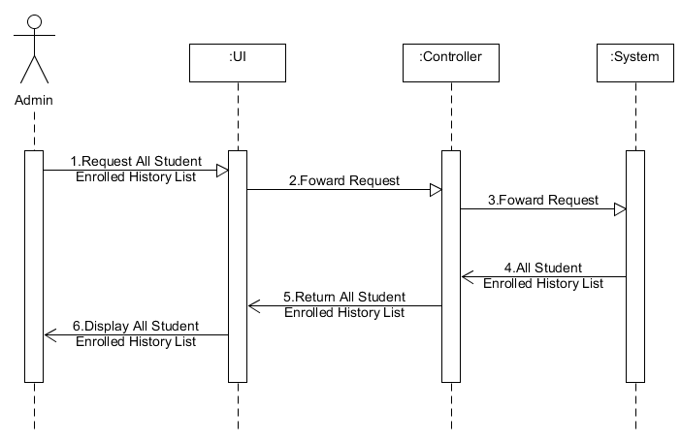

UC9: Change password

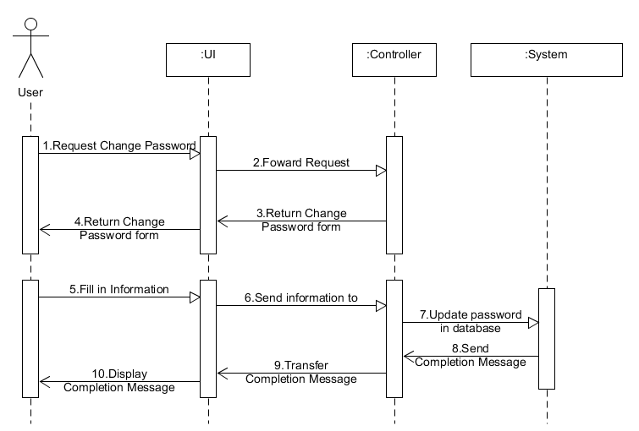

**VI. ACTIVITY DIAGRAM**

UC1: Account Registration

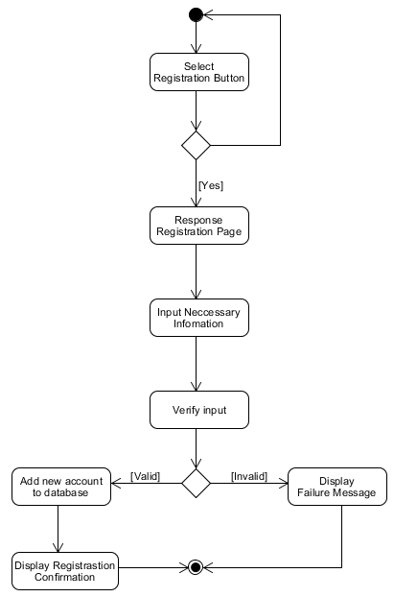

UC2: LOGIN / LOGOUT

UC2.1: Log in

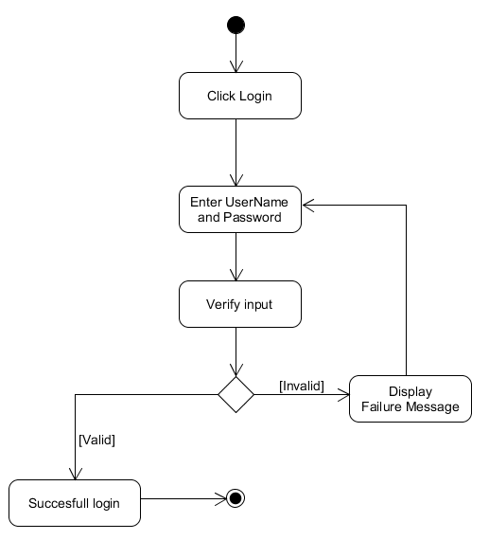

UC2.2: Log out

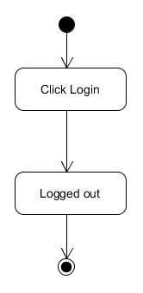

UC3: View student

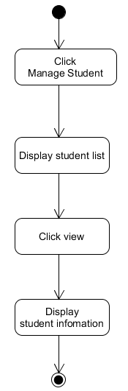

UC4: Add/Edit course

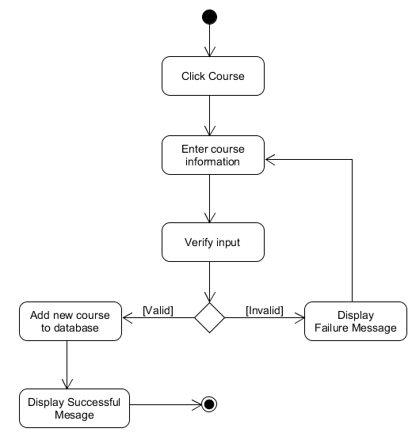

UC5: Add /Remove course (Student)

UC5.1: Add course (Student)

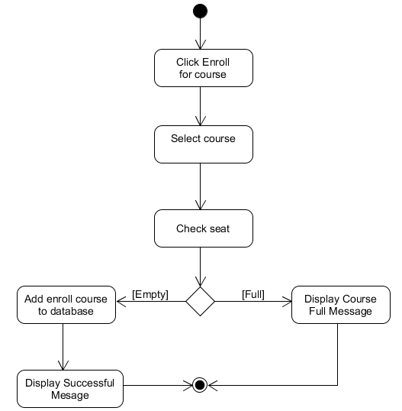

UC5.2: Remove course (Student)

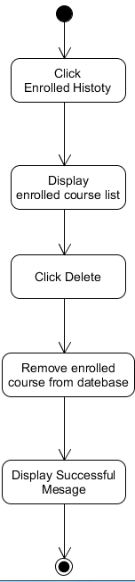

UC6: Edit student

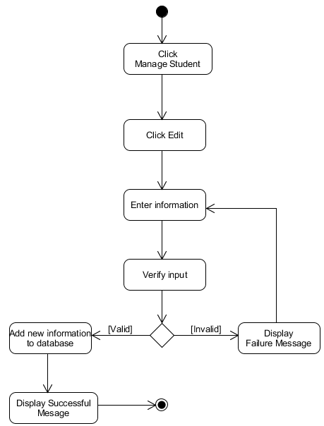

UC7: View enrolled course (Student)

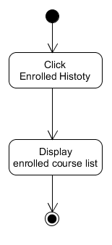

UC8: View enrolled course (Admin)

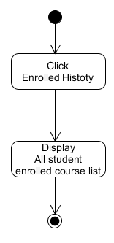

UC9: Change password

